Let’s Begin: project #1
Element and Principle: Line And Value

Artist
Jessie Knight  - Born January 8, 1904  - Comes from a family of tattoo artists  - First female artist in Britain  - Popularity peaked during WWII  American Traditional Tattooing  - First documented modern professional tattoo artist in USA was Martin Hildebrand in 1846  - Traditionally, tattoos were for people living outside constraints of society  - Freak shows, hobos, sailors  - Became popular in the military in WWII  - Characterized by thick, bold outlines, deep value, and simple color  - Easy to reproduce colors and bolder lines when out to sea  - Became symbol of the counterculture | 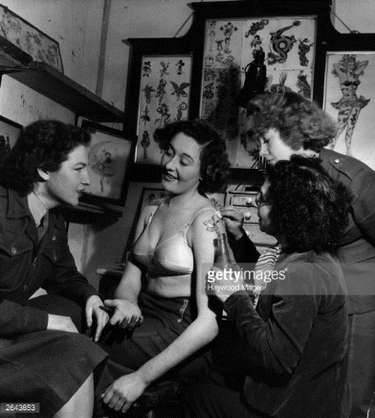

Instructions
Art 1
- This piece will be completed in pencil only
- Choose an animal and research how it is presented in American Traditional Tattooing style. Draw your animal in that style on one half of the paper. On the other half, draw the same animal in a different style
  - Tip: Differentiate between the two using different line weight
- Fill the space, and use 3+ pencil techniques learned in your demo
- You will be assessed on your use of line, as well as value and pencil techniques
Art 2
- Create a value scale on 12” x 18” paper using graphite
- Your value scale must be creative in its presentation, but still include all ten distinct values on the template provided, in order.
AP/Advanced Art
- Create a piece inspired by value. This can be something that you personally value, the value scale something that others should value, the value of money, etc.

