Stay Golden: project #4
Element and Principle: Space And Composition

Concept
Golden Ratio  Here is a 'Fibonacci series'.  0, 1, 1, 2, 3, 5, 8, 13, 21, 34, 55, 89, 144, ..  If we take the ratio of two successive numbers in this series and divide each by the number before it, we will find the following series of numbers.  1/1 = 1  2/1 = 2  3/2 = 1.5  5/3 = 1.6666...  8/5 = 1.6  13/8 = 1.625  21/13 = 1.61538...  34/21 = 1.61904...  The ratio seems to be settling down to a particular value, which we call the golden ratio(Phi=1.618..).  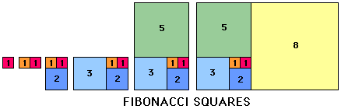 | 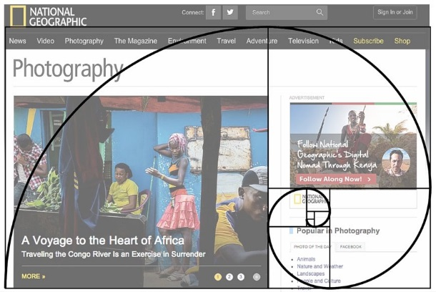  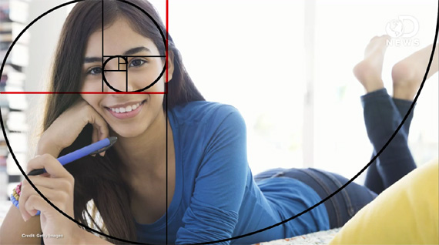

Instructions
Art 2  - Begin to consider your concentration  - Use the golden ratio squares to compose your art piece  - Use a different medium in each section  - Use chalk pastel for at least one section of your piece | Advanced/AP  - This is your first specifically concentration piece  - Use the provided handouts and previous brainstorms to begin to explore what you may want your concentration to be  - Use a variation of the golden ratio to compose your art piece  - Add a three-dimensional or interactive element to your piece

