(we’ll Never Be) Royals: project #6
Element and Principle: Shape, Color, Rhythym, Pattern

ART HISTORY
Kehinde Wiley  - Born in 1977, lives in Los Angeles  - Mother encouraged his artistic abilities  - At twenty, he traveled to Nigeria to meet his father  - References “Old Masters” with his work, mostly paints Black Americans in regal poses  - Frequently cites his sexuality as a reason for “gender-swapping” poses between male and female models  - His work is characterized by his use of patterns that overlay the figures in his pieces  - Recently commissioned to create Obama’s presidential portrait | 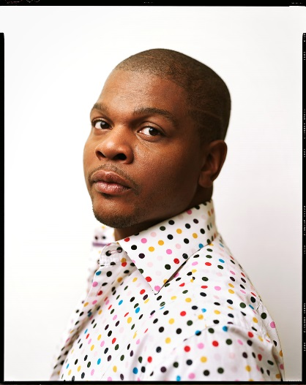

Instructions
Art 1  - Choose a person that you admire. Draw a portrait of them (either face or entire body) in pencil on the provided paper  - Trace your hands over the piece. Make sure they overlay the person in various parts.  - Erase the lines where the hands overlap to create larger shapes. Erase some parts of the person where the hands overlap them, but keep others.  - Using colored pencil, create two patterns. One should be in the hands, and the other should be outside of them. One should be warm, the other cool.  - Using colored pencil, add detail and color to the person you have drawn. | ART 2  - Create a large-scale piece about a person that you do not normally see in fine art  - 12” x 18” minimum size  - Use the provided textiles for inspiration  - Misuse positive and negative space  ADVANCED/AP ARt
- Create a large-scale piece about someone or something that you don’t typically see in fine art
- 18”x24” minimum size
- Use the provided textiles for inspiration
- Misuse positive and negative space

